
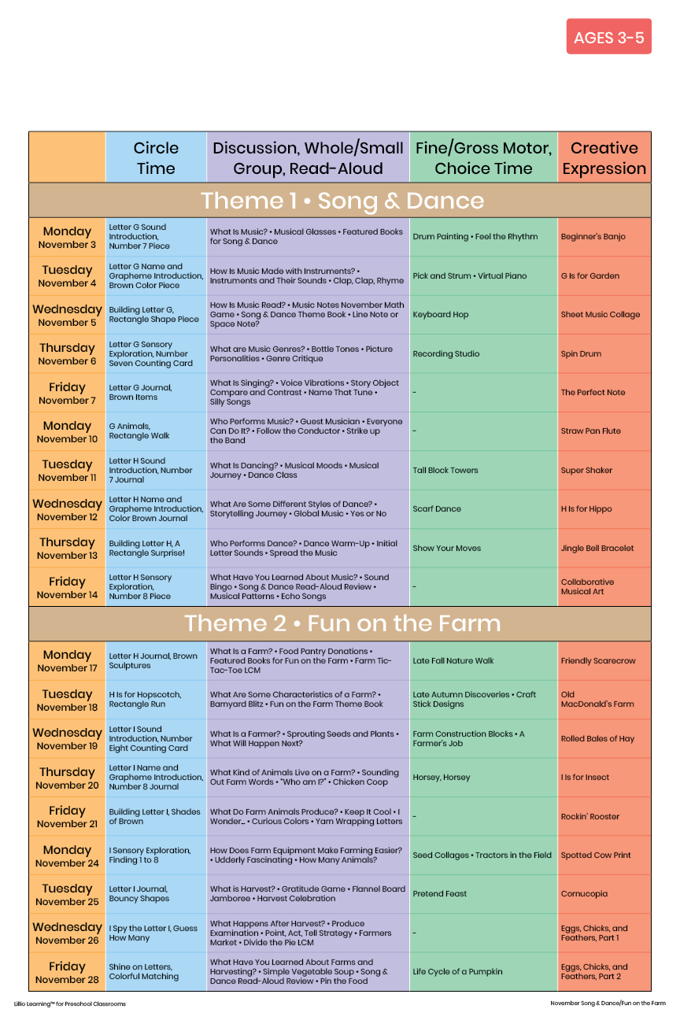
November 2025
Add Your Name/Logo Here

